**WORK INSTRUCTIONS FOR** **OPERATING CAST HOUSE CRANE (BF1 & BF2)**

**Responsibility: Furnace In charge/Foreman/Sr. Tap hole Operator**

**Identified Hazards:**

1. Fall of a person
2. Fall of jam tray
3. Snapping of wire rope
4. Impact of tray to the personnel moving around
5. Fall of material from top
6. Electric shock
7. Non use work instruction, PPE
8. Improper house keeping
9. Inadequate local lighting
10. Ignoring the person & equipment on the way of crane operation
11. Lifting the material more than its capacity
12. heat
13. Dust inhalation causing lung diseases
14. Burning due to contact with hot debris
15. Pinching between wire rope and pulley
16. Poor illumination
17. Loosening of hook lock plate bolt
18. Contact of person with crane tray
19. Entry of foreign particles in eye
20. Over traveling of crane
21. In operative limit switch
22. Impaired vision due to glare of hot metal
23. Fall of cast house crane bucket.

**Human Hazards:**

1.    Oblong operation

**Significant Aspect**

1.      Noise generation

2.      Energy consumption

**Nonstandard tools**

* Hook

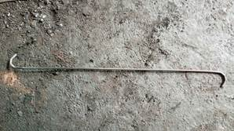

* Powda

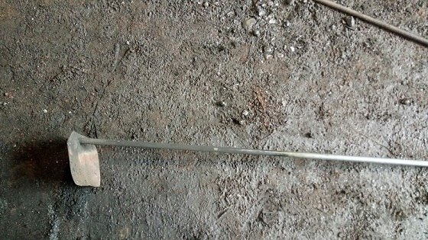

* Manual rammer

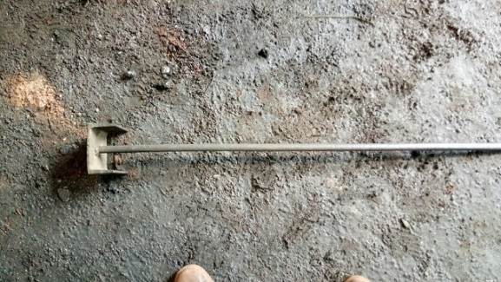

* Tool stand

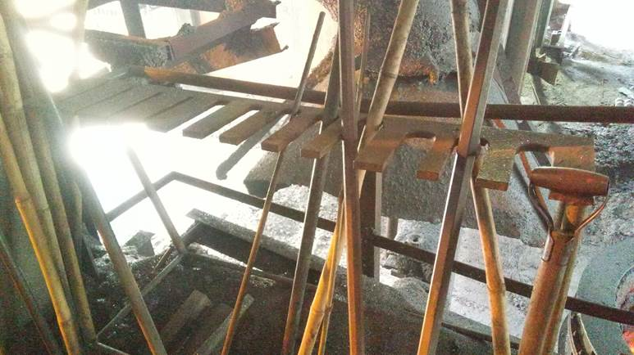

1.      Unauthorized operation or repair of any equipment is a punishable offence.

2.      Ensure that all the safety interlocks, hoist limit switch, wire rope & chain are in working condition before starting the job.

3. Check functioning of alarm system and warning lights near sliding gate before usage.

3.      Crane to be operated by trained operators only.

4.      Ensure uniform load distribution across the tray by slightly hoisting the tray, in case of imbalance rearrange the debris

5.      Ensure crane operating panel switch buttons are in place and in healthy condition. Broken/missing push button shouldn’t be operated. Get it replaced/repaired.

6.      Ensure hoisting of crane is done slowly to avoid over run of hoist cutoff limit switches and hook pulley hitting the base frame of drum.

7.      Do not operate the tray in an imbalance condition

8. Ensure that nobody is standing/moving below stationary/moving bucket

9.      Ensure that the tray does not swing during operation by locking with link chain.

10.   Nobody should follow the crane during operation; also stay away from the tray movement area.

11.  Ensure minimum clearance of the mudgun barrel while moving the tray over it.

12. Hoist limit switch should not be bypassed.

13. Radio remote is in operation for operating BF#1 5T cast house crane. Radio remote to be used only while lifting material from road level for better visibility.

13. When the 5T hoist hook is being disengaged from the tray, utmost importance and attention should be given by the person doing this activity by holding the rear end of the hook to avoid his hand/fingers getting jammed in between the tray shaft and hook.

14. In BF1 ensure -that crane is lifted to certain height so it can travel above the drill machine towards the mudgun side.

15. Ensure that the tray is not colliding with drill m/c (bf1) & mudgun (bf2) while operation.

16. Usage of 3T hoist for jam/skimmer plate removal to be done.  
Strictly avoid people going over the drill machine pipes for checking tuyer no.8.  
Usage of detachable platform provided behind drill machine to be used for checking tuyer no.8 or opening the flanges of tuyer no.8 in bf2.

17. Use water spray before dumping debris to avoid dust generation.

18.  Dump the debris from the tray at the edge of the sand stacking platform of the cast house by lowering the wire rope

19.  Before dumping debris ensure that chain is placed & no one is standing near the dumping area.

20. Person operating the crane has to ensure that no body is coming from the GCS side in CH while operating.

21. Everyone should to wear full sleeve shirt in HMH area.

22. Bag house has to be always ensured for its effectiveness; any issues related to suction has to be immediately taken up for rectification.

23. Mono goggles to be used in cast house.

24. Periodic cleaning to remove graphite deposition.

|  |  |  |
| --- | --- | --- |
| **Prepared By:**  Head – Production PID I | **Reviewed & Issued By:**  Management Representative | **Approved By:**  Head – Pig Iron Division |
| **Signature:** | **Signature:** | **Signature:** |
| **Date: 01.12.2022** | **Date: 01.12.2022** | **Date: 01.12.2022** |

|  |  |  |  |
| --- | --- | --- | --- |
| **Amendment Record** | | | |
| **Revision date** | **Manual Section ref. and para** | **Brief details of revision** | **New Revision No.** |
| 12.07.2021 | Procedure for operating cast house crane (BF1&BF2) | Point no 23 | 08 |
| 15.07.2022 | Procedure for operating cast house crane (BF1&BF2) | Change in format | 09 |
| 01.12.2022 | Procedure for operating cast house crane (BF1&BF2) | Point no.13 added  Hazard no.23 added | 10 |